**Basics of IP Addresses in Computer Networking**

Each device connected to the internet has a unique identifier. Most networks today, including all computers on the internet, use the **TCP/IP a**s a standard to communicate on the network. In the TCP/IP protocol, this unique identifier is the **IP Address**. The two kinds of IP Addresses are **IPv4** and **IPv6**.

**IPv4 vs IPv6**

**IPv4** uses 32 binary bits to create a single unique address on the network. An IPv4 address is expressed by four numbers separated by dots. Each number is the decimal (base-10) representation for an eight-digit binary (base-2) number, also called an octet.

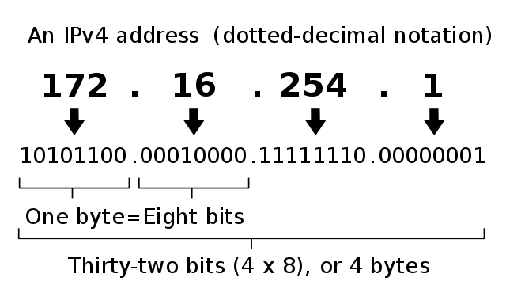

**IPv6** uses 128 binary bits to create a single unique address on the network. An IPv6 address is expressed by eight groups of hexadecimal (base-16) numbers separated by colons. Groups of numbers that contain all zeros are often omitted to save space, leaving a colon separator to mark the gap .

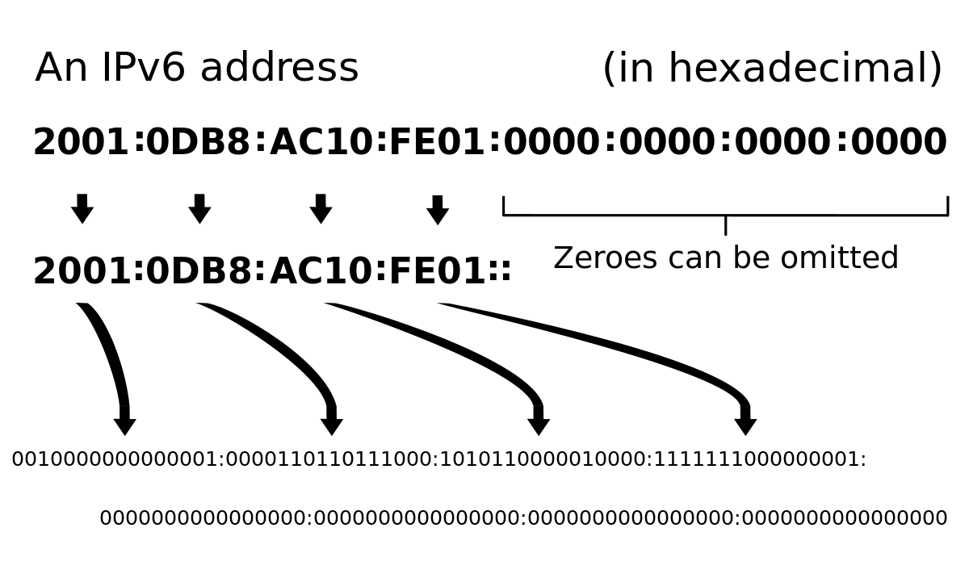

IPv6 space is much larger than the IPv4 space due the use of hexadecimals as well as having 8 groups. Most devices use IPv4. However, due to advent of IoT devices and the greater demand for IP Addresses, more and more devices are accepting IPv6.

**Static vs Dynamic**

How does your computer get its IP address? An IP address can be either dynamic or static.

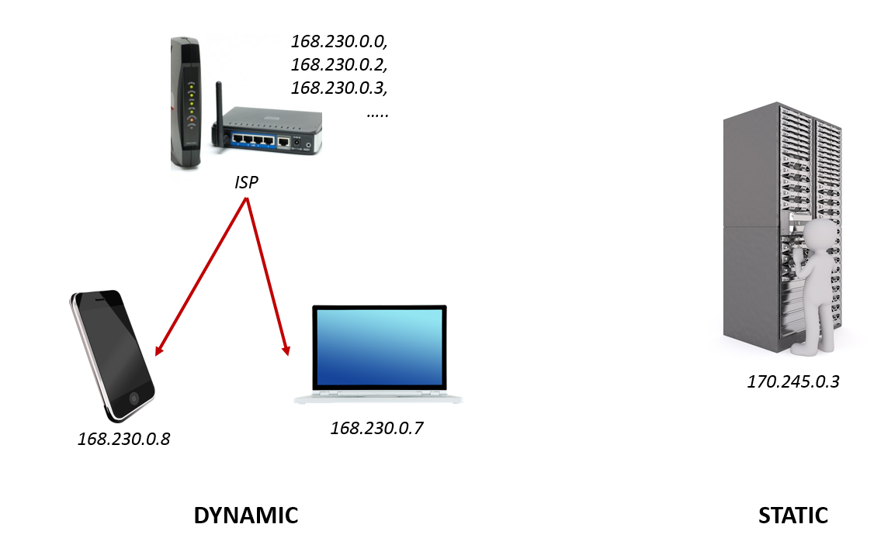

**Static**address is one that you configure yourself by editing your computer’s network settings. This type of address is rare, and it can create network issues if you use it without a good understanding of TCP/IP.

**Dynamic**addresses are the most common. They’re assigned by the Dynamic Host Configuration Protocol (DHCP), a service running on the network. DHCP typically runs on network hardware such as **routers**or dedicated DHCP servers. Dynamic IP addresses are issued using a leasing system, meaning that the IP address is only active for a limited time. If the lease expires, the computer will automatically request a new lease.

**IP Classes**

Typically, the IPv4 space allows us to have addresses between **0.0.0.0** to **255.255.255.255**. However, some numbers in that range are reserved for specific purposes on TCP/IP networks. These reservations are recognized by the authority on TCP/IP addressing, the Internet Assigned Numbers Authority (IANA). Four specific reservations include the following:

* **0.0.0.0**— This represents the default network, which is the abstract concept of just being connected to a TCP/IP network.
* **255.255.255.255** — This address is reserved for network broadcasts, or messages that should go to all computers on the network.
* **127.0.0.1** — This is called the loopback address, meaning your computer’s way of identifying itself, whether or not it has an assigned IP address.
* **169.254.0.1**to**169.254.255.254**— This is the Automatic Private IP Addressing (APIPA) range of addresses assigned automatically when a computer’s unsuccessful getting an address from a DHCP server.

The other IP address reservations are for **subnet classes**. A **subnet**is a smaller network of computers connected to a larger network through a router. The subnet can have its own address system so computers on the same subnet can communicate quickly without sending data across the larger network. A router on a TCP/IP network, including the Internet, is configured to recognize one or more subnets and route network traffic appropriately. The following are the IP addresses reserved for subnets:

* **10.0.0.0** to **10.255.255.255** — This falls within the Class A address range of **1.0.0.0** to **127.0.0.0**, in which the first bit is 0.
* **172.16.0.0** to **172.31.255.255** — This falls within the Class B address range of **128.0.0.0** to **191.255.0.0**, in which the first two bits are 10.
* **192.168.0.0** to **192.168.255.255** — This falls within the Class C range of **192.0.0.0** through **223.255.255.0**, in which the first three bits are 110.
* Multicast (formerly called Class D) — The first four bits in the address are 1110, with addresses ranging from **224.0.0.0** to **239.255.255.255**.
* Reserved for future/experimental use (formerly called Class E) — addresses **240.0.0.0** to **254.255.255.254**.

The first three (within Classes A, B and C) are those most used in creating subnets. Later, we’ll see how a subnet uses these addresses. The IANA has outlined specific uses for multicast addresses within Internet Engineering Task Force (IETF) document [RFC 5771](http://tools.ietf.org/html/rfc5771). However, it hasn’t designated a purpose or future plan for Class E addresses since it reserved the block in its 1989 document [RFC 1112](http://tools.ietf.org/html/rfc1112). Before IPv6, the Internet was filled with debate about whether the IANA should release Class E for general use.

**Subnets**

When you type (**ipconfig)** on your UNIX terminal (or CMD prompt for Windows users), you will get a pretty detailed display of your IP Address information. I have taken a screenshot of the section that I am interested in.

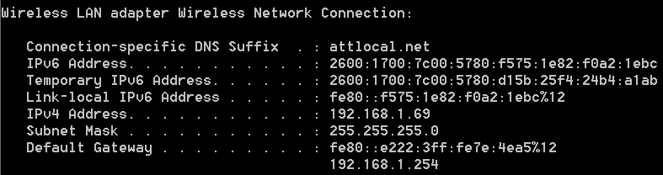

ipconfig partial output

* IP address: **192.168.1.69**
* Subnet mask: **255.255.255.0**
* Twenty-four bits (three octets) reserved for network part
* Eight bits (one octet) reserved for host part
* Subnet identity based on subnet mask (first address): **192.168.1.0**
* The reserved broadcast address for the subnet (last address): **192.168.1.255**
* Example addresses on the same network: **192.168.1.1**, **192.168.1.103**
* Example addresses not on the same network: **192.168.2.1**, **192.168.2.103**

IP addresses on a subnet have two parts: **network**and **node**. The network part identifies the subnet itself. The node, also called the host, is an individual piece of computer equipment connected to the network and requiring a unique address. Each computer knows how to separate the two parts of the IP address by using a **subnet mask**. A subnet mask looks somewhat like an IP address, but it’s actually just a filter used to determine which part of an IP address designates the network and node.

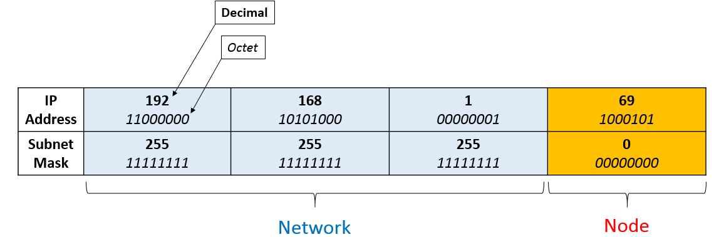

In the current situation, the subnet mask is 255.255.255.0, indicating that 1 byte being dedicated for the host. It can also be 255.255.0.0 (2 byes) and 255.0.0.0 (3 bytes).